Personnel Profile

Shri. VINOD B.RAHUT  LECTURER  Department of History  KLE’s SK Arts College and HSK Science Institute,  Hubballi – 580031, Dharwad (D), Karnataka, India  Mobile-+91 8971475021  Email: rahutvinod@gmail.com | 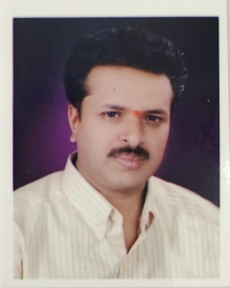

Education Details:

Sl.No. | Exam Passed | Board/ University | Year of Passing
1. | MPHIL (Education) | SV University,Tirupati | 2007
2. | MED | Karnatak University, Dharwad | 2001
3. | M.A. | Karnatak University, Dharwad | 2000

Computer Literacy: Basic Computer

Teaching Experience:

Sl.No. | Institution | Year |  | No. of Years
Sl.No. | Institution | From | To | No. of Years
3 | KLE SKA College and HSK Sc. Inst., Hubballi | 2017 | Till date | 5

Member of Professional Bodies:

- Member of Indian History Congress

Research Interests:
- Indian Tourism
Research Experience:

- As a MPhil. student at Karnatak University, research was mainly focussed on Indian Education System.

National/International conferences, seminars, workshops, symposium participated:
Sl.No | Title | Role | Dates From – to | Place
01 | Workshop on UG Revised History syllabus | Participant | 30 Nov 2018 | Karnatak University, Dharwad
02 | Workshop on UG Revised History syllabus | Participant | 08 Nov 2019 | GFGC Dharwad
03 | Seminar on The Concept of Social Democracy In India | Participant | 13 Sep 2021 | KCD Dharwad
04 | Workshop on NEP & History Curriculum | Participant | 02 Oct 2021 | KCD Dharwad

Posts Held & Institution Governance Responsibility:

Sl.No. | Event | Responsibility Held
01 | NAAC Criterion-V | Member
02 | UBA Belagali Village | Member

Personal Details:

Official/Mailing Address | Department of History  KLE’s SK Arts College and HSK Science Institute, Hubballi-580031  Dharwad (D), Karnataka, India
Permanent Address | At/Pt M K Hubli  Tq Kittur  Dst Belagavi, 591118  Karnataka, India
Phone number | Mobile: +91 8971475021
E-mail | rahutvinod@gmail.com
Nationality | Indian
Date of birth | 22-07-1974
Languages known | Kannada, English, Hindi Marathi (Read, Write and Speak)

