Personnel Profile

Shri. BASAVARAJA G JIGALI  Assistant Professor  Department of History  KLE’s SK Arts College and HSK Science Institute,  Hubballi – 580031, Dharwad (D), Karnataka, India  Mobile-+91 9901570874  Email: basavarajigali00@gmail.com | 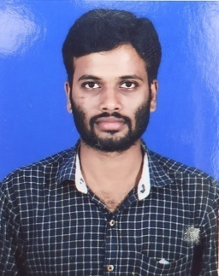

Education Details:

Sl.No. | Exam Passed | Board/ University | Year of Passing
1 | Ph.D. | Karnatak University, Dharwad | 2022
2 | M.A. | Karnatak University, Dharwad | 2015

Computer Literacy: Basic Computer

Teaching Experience:

Sl.No. | Institution | Year |  | No. of Years
Sl.No. | Institution | From | To | No. of Years
3 | KLE SKA College and HSK Sc. Inst., Hubballi | 2019 | Till date

Member of Professional Bodies:

- Life Member of Karnataka History Congress (M.No.: 2021941)
- Member of Indian History Congress

Posts Held & Institution Governance Responsibility:
Sl.No. | Event | Responsibility Held
01 | UBA Chikkanrti Village | Co-ordinator
02 | UUCMS | Nodal Officer
03 | College Union | Member
04 | NAAC Criterion-II | Member
05 | Auditorium | In charge
06 | Garden Committee | Member
07 | I A Committee | Member

Orientation/Refresher Course/ FDP Attended:

- Four weeks Orientation programs for faculty in universities/colleges/institutes of higher education from 4th June 2020 to 1st July 2020 organized by Ramanujan College, Delhi

Special Lectures Delivered:

- Delivered a online lecture on Position of Women in Ancient India held on 04-09-2021organized by SJMVS Women’s college, Hubballi.

Research Interests:

- Modern Indian History
- Ancient and Medieval Indian Society and religion
Research Experience:

- As a Ph.D. student at Karnatak University, research was mainly focussed on Modern Indian History.

Papers presented at various International/National conferences, seminars, workshops:

Karnataka History Congress | Participant & Presented a Paper | 22nd to 24th March 2021 | Karnatak University, Dharwad

Personal Details:

Official/Mailing Address | Department of History  KLE’s SK Arts College and HSK Science Institute, Hubballi-580031  Dharwad (D), Karnataka, India
Permanent Address | At/Pt Nagavanda  Tq Rattihalli  Dst Haveri, 581210  Karnataka, India
Phone number | Mobile: +91 9901570874
E-mail | basavarajigali00@gmail.com
Nationality | Indian
Date of birth | 06th December 1991
Languages known | Kannada, English, Hindi (Read, Write and Speak)

