Personal Profile

Smt.Sujata S Patted  Assistant Professor  Department of English  KLE’s SK Arts College and HSK Science Institute,  Hubballi – 580031, Dharwad (D), Karnataka, India  Mobile-+91 9538520716  Email: sujatha.patted@gmail.com | 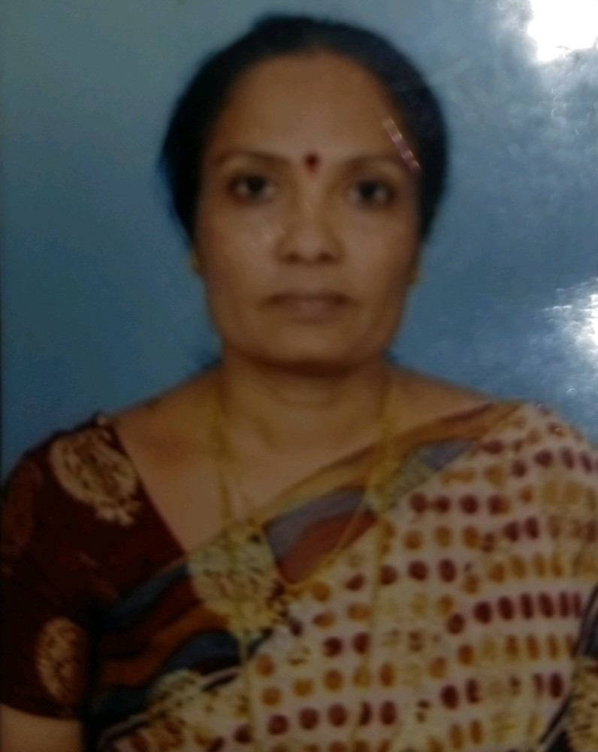

Education Details:

Sl.  No. | Exam  Passed | Board/ University | Year of Passing
1 | M.Phil | Venkateshwar University, Tamilnadu | 2008
2 | M.A | K.U.D | 1988

Computer Literacy: Yes

Teaching Experience:

Sl.No. | Institution | Year |  | No. of Years
Sl.No. | Institution | From | To | No. of Years
1 | P.C Jabin Science College, Hubballi | 1988 | 2005 | 18
2 | S.K Arts College & H.S.K Science Institute,Hubballi | 2005 | Till Date | 16

Member of Professional Bodies:
- Kannada Sahitya Parishat
- Karnataka University College Teachers Association
- Karnataka University English Teachers Forum

Memberships in Editorial Boards:
Editor of College Magazine ‘ARIVU’

Posts Held & Institution Governance Responsibility:
Head of the Department -2006
NCC Officer 2004 -2013
Member of IQAC

Refresher Course Attended:
Venue | Dates
Jawaharlal Nehru Technological University,  Hyderabad | 2-12-2019 to 14-12-2019
MOOC- ARPIT | 30-04-2020

Research Projects:

Sl.No. | Major/Minor | Title | Organization | Amount
1 | Minor-2012 | English Language Learning & Teaching at UG level in Koppal District (Hyderabad Karnataka Region) | UGC | Rs.1,20,000/

Publications in Conference Proceedings:

Sl No | Title | Authors | NameConf/Sem/  workshop | Venue | Date | Year
1 |  | Smt.Sujata Patted | Three Day Inte'l Conference |  |  | 2017-18
  Are Finishing
  Schools
  Inevitable?
  St.Teresa College Ernaculam
  Kerala
  29th, 30th June & 1st July 2017
2 | Eng Language & Literature :Some Perspectives | Smt.Sujata Patted | One Day Workshop | Karnataka University,Dharwad | 19th May 2018 | 2018-19

Papers presented at various International National Conferences, Seminars, Workshops:

Sl No | Title | Authors | Conf/Sem/  Workshop | Venue | Date | Year | ISBN/ISSN
1 |  | Smt.Sujata Patted | Three Day International Conference |  |  | 2017-18 | Proceedings
  Are Finishing
  Schools
  Inevitable?
  St.Teresa College Ernaculam
  Kerala
  29th, 30th June &
  01st -Jul-2017
2 | Pt.Deen Dayal Upadhya-A Versatile Personality | Smt.Sujata Patted | Two Day International Seminar | S.K.A & H.S.K,Science Institute, Hubballi | 6th&7th Oct,2017 | 2017-18 | ISBN
3 | ICT-A Challenging Path | Smt.Sujata Patted | One Day National Conference | Anjuman,Arts & Sc Clg,Dwd | 09th-march-2019 | 2018-19 | ISSN
4 | Basavanna's Concern for Women | Smt.Sujata Patted | One Day International Conference | AGNM Arts & Commerce Degree College | 22nd-Sept-2019 | 2019-20 | ISBN

National Conferences, Seminars, Workshops participated:

Sl No | Title | Conf/Sem/  Workshop | Venue | Date | Year
1 |  | Three Day State Level Workshop | S.K.A & H.S.K,Science, Institute, Hubballi | 14th,15th, & 16th April, 2017 | 2017-18
  NET/SLET & P.U Lecturership
  Recruitment
2 | Theoritical & Modern Trends in Research | One Day Nat'l Seminar | Mrutyunjaya College, Dharwad | 20th Oct 2017 | 2017-18
3 |  | Two Day International Conference | S.K.A & H.S.K Science Institute, Hubballi | 7th & 8th Sept, 2018 | 2018-19
  Role of Literature & Journalism in Context of
  Nationalism in Pre-Independence India
4 | Professional Ethics &Values for Quality Enhancement | UGC: One Day National Workshop | P.C.Jabin Science College, Hubballi | 3rd Oct 2018 | 2018-29
5 | English Language & Literature  : Some Perspectives | One Day Workshop | Karnataka University,  Dharwad | 19th May 2018 | 2018-19

Participation in International & National Webinars

Sl.No | Title | Conf/Sem/  workshop | Venue | Date | Year
1 | Introduction to Literature | National Webinar | Thiruvalluvar  University,  Constitutent Colleges of Arts& Science, Kallakurichi | 21st June 2020 | 2020-21
2 | AQAR Writing& Submission As Per New NAAC Guidelines | Two Days National Webinar | Miraj Mahavidyalaya ,Miraj | 6th & 7th June,2020 | 2020-21
3 | Opportunities and Challenges in Outcome Based Education | National Webinar | Raja Lakhamagouda Science Institute (Autonomous), Belagavi - 590001 | 8th June,2020 | 2020-21
4 | In-spite of...Attitude | International Webinar | Arts and Commerce College, Gadag | 9th June, 2020 | 2020-21
5 | "MOOCs: A Platform for Online Lea  rning | National Webinar Series-2020 | S.K.Arts College & H.S.K Science Institute,Hubballi | 22nd July 2020. | 2020-21
6 | Nanoworld and Soft Matter: Science & Technology without  Boundaries” | National Webinar Series-2020 | S.K.Arts College & H.S.K Science Institute,Hubballi | 16th July 2020. | 2020-21
7 | Socio-Economic Development in the perspective of Post COVID-19  Rural India” | National Webinar Series-2020 | S.K.Arts College & H.S.K Science Institute,Hubballi | 20th July 2020. | 2020-21
8 | Challenges infront of a reporter during Covid 19 pandemic | National Webinar Series-2020 | S.K. Arts College & H.S.K Science Institute, Hubballi | 10th July,2020 | 2020-21
9 | Applications of Remote Sensing and GIS" and  "Man and Environment Interrelationships: Case Studies based on Sites and Associations | National Webinar Series-2020 | S.K. Arts College & H.S.K Science Institute, Hubballi | 15th July 2020 | 2020-21
10 | The Role Of United Nations in the contemporary World | National Webinar Series-2020 | S.K.Arts College & H.S.K Science Institute,Hubballi | 15th July,2020 | 2020-21
11 | ಶಾಸನಗಳಲಿಲ್ಲಿ ಆತ್ಮ ಬಲಿದಾನ ಪರಿಕಲ್ಪನೆ | National Webinar | S.K.Arts College & H.S.K Science Institute,Hubballi | 17th July,2020 | 2020-21
12 | Optimism & Well-being | National Webinar | S.K.Arts College & H.S.K Science Institute,Hubballi | 21st July 2020 | 2020-21
13 | Recreational Problems in Graph Theory and their  Applications in Real World” | National Webinar | S.K.Arts College & H.S.K Science Institute,Hubballi | 13th July 2020 | 2020-21
14 | COVID-19 & Indian Economy | National Webinar | SKA S.K.Arts College & H.S.K Science Institute,Hubballi | 07th October 2020 | 2020-21
15 | Healthy Food for Healthy Life- Eat Right to Nourish You | National Webinar | Shrimati Devkunwar Nanalal Bhatt Vaishnav College for Women Chromepet, Chennai | 4th June,2020 | 2020-21
16 | Developing Core Skills in Classroom | International Webinar | Nesamony Memorial Christian College,Tamilnadu | 20th June,2020 | 2020-21
17 | The Power of Feedback in Higher  Education Institution” | National Webinar | S.K.Arts College & H.S.K Science Institute,Hubballi | 19th Sept,2020 | 2020-21
18 | Identifying Weaker Students & Remedial Actions | National Webinar | INPODS | 2nd May,2020 | 2020-21
19 | Assertiveness | National Webinar | Society's Arts and Commerce College, Gadag | 4th May,2020 | 2020-21
20 | Finding and Owning Your Voice” | National Webinar | Arts and Commerce College, Gadag | 19th July,2020 | 2020-21
21 | Use of Google classroom for Teaching & Learning | Workshop | Mumbai Network of English Teachers | 16th August,2020 | 2020-21
22 | Demand Driven Local Innovations as an Enabler for Self-reliance” | National Webinar | S.K Arts College and H.S.K Science Institute, Hubballi | 04th May 2021 | 2020-21
23 | “Restore Our Earth | National Webinar | S.K Arts College and H.S.K Science Institute,  Hubballi | 22nd April 2021. | 2020-21
24 | Publication Metrics” | National Webinar | S.K Arts College and H.S.K Science Institute,  Hubballi | 3rd May ,2021 | 2020-21
25 | Covid-19 associated Mucormycosis (Black  Fungus)”- | National Webinar | S.K Arts College and H.S.K Science Institute,  Hubballi | 25th May 202 | 2020-21
26 | Intellectual Property Rights | National Workshop | S.K Arts College and H.S.K Science Institute,  Hubballi | 29th  May 2021. | 2020-21
27 | Save the Planet Ride the Bike-When  in Doubt Pedal it Out”, | National Webinar | S.K Arts College and H.S.K Science Institute,  Hubballi | 03rd June 2021 | 2020-21
28 | National Education Policy- 2021 | National Webinar | Central University of Karnataka, Dept of Economics | 8th Sept,2020 | 2020-21
29 | Choice Based Credit System in KUD’ | University Level Webinar | Nehru Arts, Science, Commerce College & PG Centre,Hubballi | 24th July 2020. | 2020-21
30 | Role Of IQAC In NAAC Accreditation Process and  Attainment Calculation” | National Webinar | Shri Shivayogi Murughendra Swamiji Arts, Commerce  and Science College Athani- 591304, Karnataka. | 30th May,2021 | 2020-21
31 | “Values & Ethics for  Academic Leadership | National Webinar | S.K Arts College and H.S.K Science Institute,  Hubballi | 8th March,2021 | 2020-21
32 | Cohesive Team Building | National Webinar | S.K Arts College and H.S.K Science Institute,  Hubballi | 15th March,2021 | 2020-21
33 | “Role of NSS Volunteers in Disaster Management” | State Level Special Lecture | S.K Arts College and H.S.K Science Institute,  Hubballi | 11th June.2021 | 2020-21
34 | Need for Developing Gender Sensitivity during the Pandemic Times | National Webinar | S.K Arts College and H.S.K Science Institute,  Hubballi | 09th June 2021 | 2020-21
Quiz Programmes Attended
Sl No | Title | Venue | Date | Year
1 | COVID-19 Social Awareness Quiz | Department of Collegiate Education  GFGC, Kaladagi Dist:Bagalkot | 30-5-2020 | 2020-21
2 | NAAC Awareness Quiz" | Commerce, BHS Arts & T.G.P Science College,Jamakhandi | 5-3-2020 | 2019 - 20
3 | Scientific Awareness of  COVID-19 | Shri Shivayogi Murughendra Swamiji Arts, Commerce  And Science College Athani, Karnataka. | May 2020 | 2019 - 20
4 | English Language Proficiency | Lokseva Education Society’s  Arts & Science College, Aurangabad | 10-5-2020 | 2019 - 20
5 | Verbal Proficiency | Shri Krishna Aditya College of Arts & Science Koviapudur, Coimbattur | 4-5-20 | 2019 - 20
6 | Covid 19 Pandemic Awareness Quiz | SVM Arts, Science and Commerce  College, ILKAL, | 17-5-2020 | 2019 – 20

Personal Details
Official/Mailing Address | KLE Society, S K Arts College and H S Kotambri Science Institute Hubballi -580031
Permanent Address | Patted’s Opposite to Empire Square, Shirur Park, Vidyanagar, Hubballi 580021
Phone number | 9538520716
E-mail | sujatha.patted@gmail.com
Nationality | Indian
Date of birth | 29-10-1965
Languages known | Kannada, English ,Hindi

Note:

- Font Size 12 Times New Roman
- Delete the things which are not applicable to You
- Add the Rows and Columns if required and Hide the Columns and Rows after
writing all the details
- Keep the hard copy in department and department wise soft copies should be added
to PC in Principals Chamber
- All must maintain the same Profile
- Submit the Soft copy by 03-02-2021 by 5.00pm without fail
- Delete this Note

